Tutorial 9.1

# Part 1

### Step d:

Columns of COEFF against input weights, have roughly linear relationship

The first column of COEFF has a denser distribution than the second column.w

two plots always have opposite slope signs.

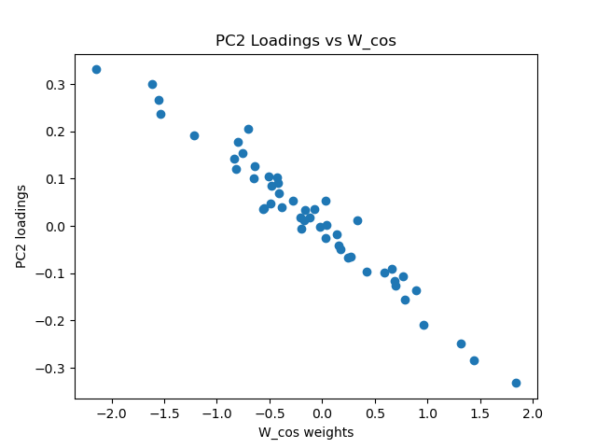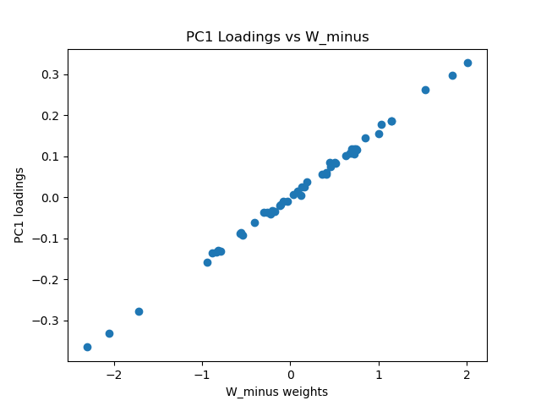

### Step e

PC 1 accounts for almost all of the variance (→ ~95 %+),

because the ramp runs continuously and dominates the firing rates.

PC 2 explains only (< 5 %), just enough to capture the one‑second transient

higher PCs account for negligible, mostly noise variance.

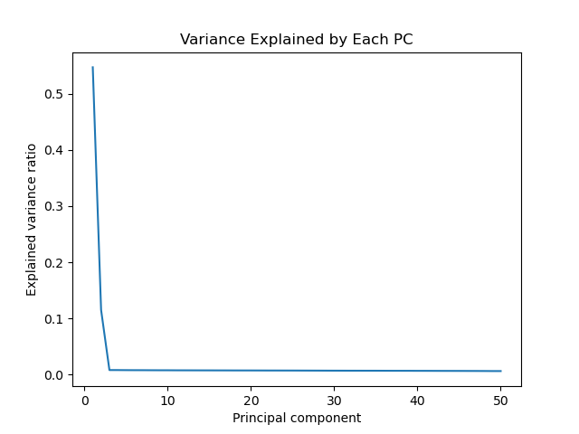

### Step G

Compare the behavior of the denoised data with the original data

For two example neurons, the denoised traces (reconstructing only PCs 1–2) retain the smooth ramp plus the transient bump while discarding the high‑frequency noise. This shows that those two components suffice to reconstruct the core dynamics.

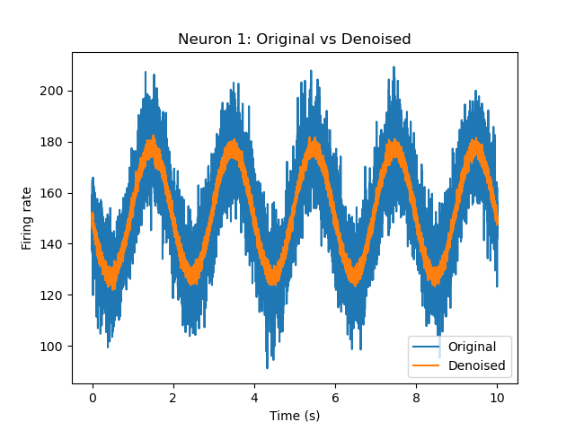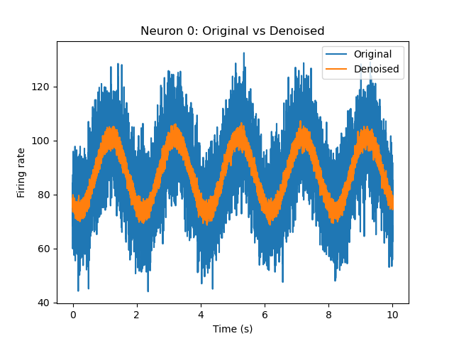

### Step h

Plots of Rate of a Neuron to another: Original and Denoised

**Before denoising**, the scatter of neuron 0 vs. neuron 1 rates is a broad, fuzzy cloud,

**After denoising**, the points collapse onto a much tighter ellipse 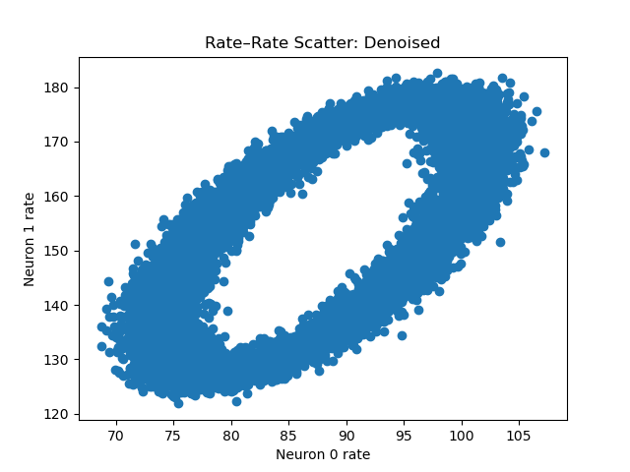

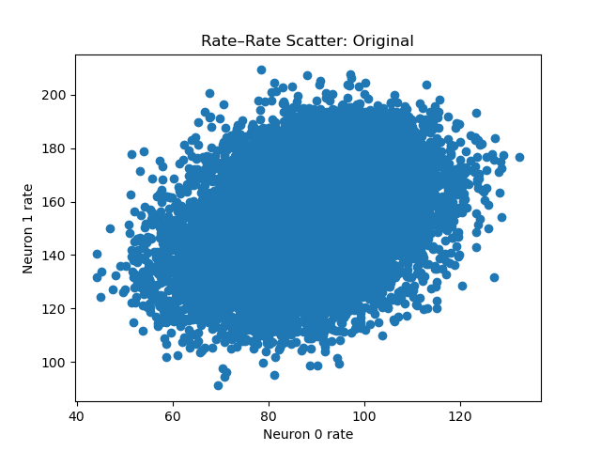

### Step i

Plots of matrix SCORE

Both traces oscillate at around 0.5 Hz, PC 1 has a larger amplitude.

PC 1 isolates the sine input (larger amplitude, zero‐cross at t=0).  
PC 2 isolates the cosine input (90° phase shift, smaller amplitude).  
 Together they recover the two underlying oscillatory drives from the noisy population data.

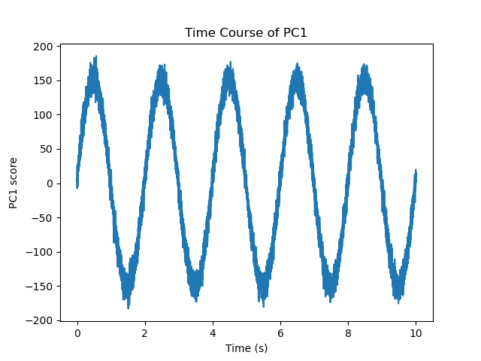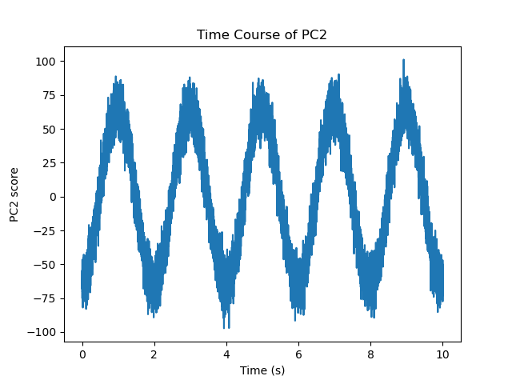

# Part 2

f_A = 1 Hz, f_B = 0.5 Hz

In PC1, the tight negative slope shows that neurons with stronger (more positive) sine weights load more strongly

Input weights Wcos​ have larger PC 2 loadings. That confirms PC 2 is the cosine component.

Columns of COEFF against input weights,

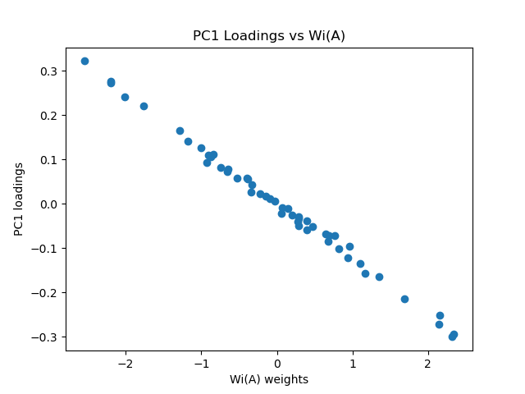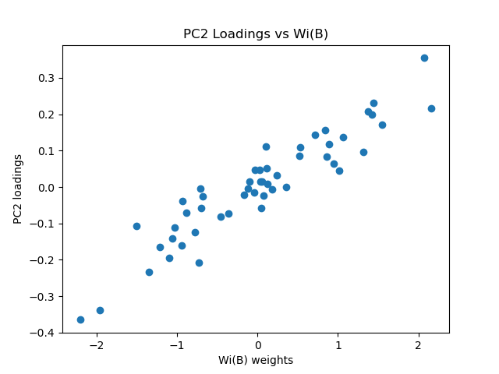

Step e

Same pattern as part 1.

PC 1 captures ~60% of the total variance (the dominant sine oscillation), PC 2 about ~10%

EXPLAINED

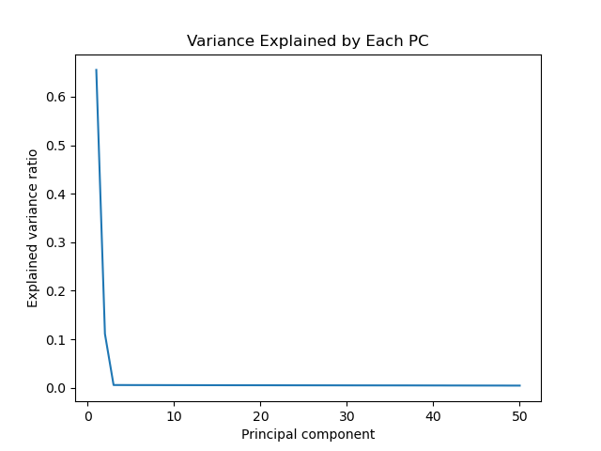

Step G

Similar as part 1

The effect of denoise differs in neurons.

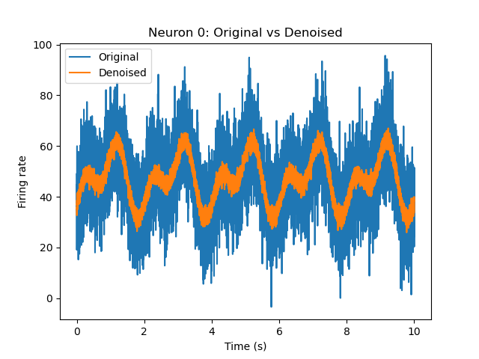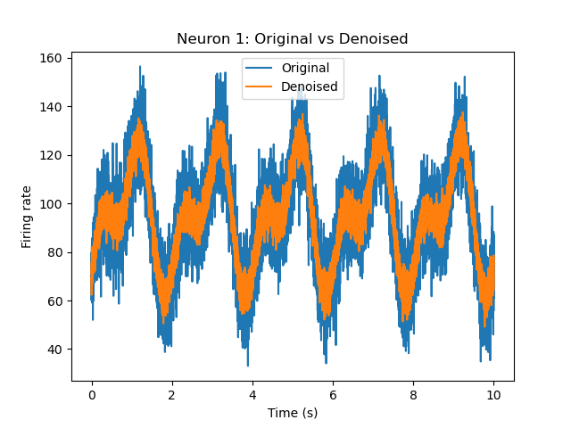

Step h

Plotting neuron 0’s rate versus neuron 1’s produces a diffuse blob—noise makes their relationship look messy, even though they share the same two driving oscillations.

In plot 2 noise is removed. The rate-rate scatter is a more narrow ellipse.

Plots of Rate of a Neuron to another: Original and Denoised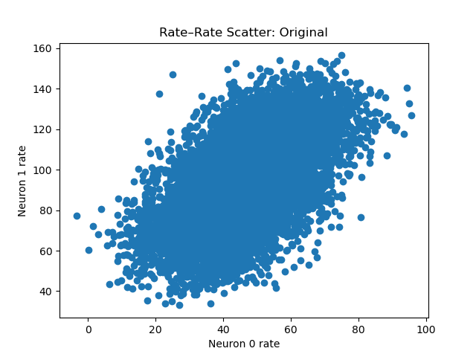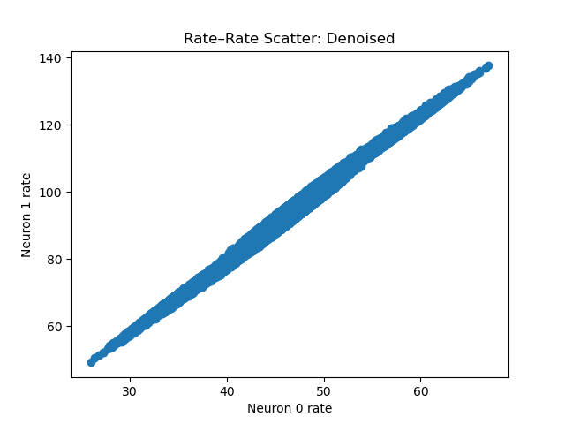

Step i

PC1 oscillates a time quicker than PC2. PC2 shifts by 90 degrees.

Plots of matrix SCORE

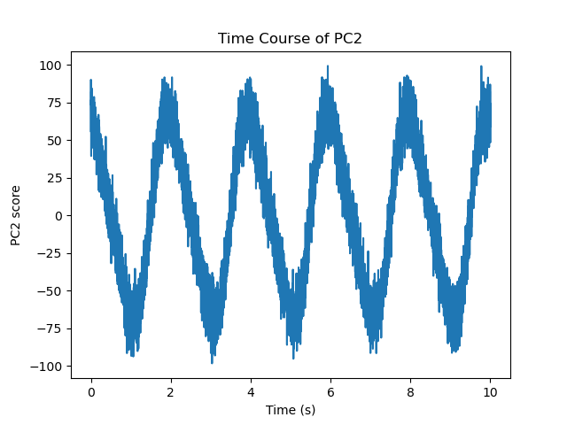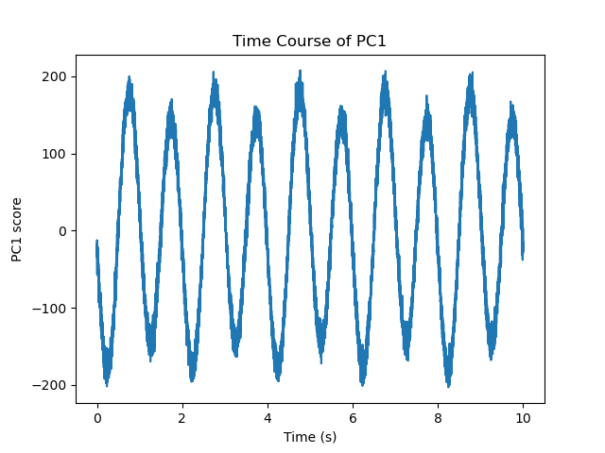

Part 3

PC 2 has zeroed in on the brief 4–5 s sine pulse.

Variance explained has a similar pattern to before.

PC time courses

PC 1 climbs linearly over the full 0–10 s window, mirroring I1

PC 2 stays near zero except for a pronounced bump exactly during the 4–5 s window, matching the brief sine burst in I2​.

Original vs. denoised firing‑rate traces  
For two example neurons, the denoised traces (reconstructing only PCs 1–2) retain the smooth ramp plus the transient bump while discarding the high‑frequency noise. This shows that those two components suffice to reconstruct the core dynamics.

Rate–rate scatter plots

Before denoising, the scatter of neuron 0 vs. neuron 1 rates is a cloud. After denoising, the points collapse onto a much tighter curved band.

